Project-1:

CBI Program Evaluation

Submitted to:

Dr. Leping Liu
Associate Professor, Dept of CEP
& Instructor of the Course CEP-612
Spring-2008 Semester
University of Nevada, Reno

Presented by:

Mokter Hossain
Graduate Student, Dept of CEP
University of Nevada, Reno
www.Mokter.5u.com

- Introduction

This is, Project-1: CBI Program Evaluation, is an important part of CEP-612: Method of Using Information Technology in Teaching and Learning Course. This time I did web search, find and evaluate, and learned a lot of useful issues related to CBI design. All these activities seem to very useful to reshape, clarify, and update my knowledge and idea, that I have had, and I gained during the past reading assignments and lab activities of this course. Obviously, these idea will encourage me to design new and more interactive CBI programs, that will be very helpful to expertise my teaching-learning skills.

2. Table of Contents

Topic/Title | Page No
- Introduction | 1
- Table of Contents | 3
- Evaluation Checklist | 4
- Evaluation Score-sheets | 6
- Evaluation Score-sheet-1 | 6
- Evaluation Score-sheet-2 | 8
- Evaluation Score-sheet-3 | 10
- Evaluation Score-sheet-4 | 12
- Evaluation Table and Chart | 14
- Evaluation Report | 15
- Math Game | 15
- Introduction to Swim Workout | 16
- Shortest Distance between two Points on a Plane | 17
- How to Create a Digital Story | 18

3. Evaluation Checklist

CBI Software title: _____________________________________
URL of the CBI: _______________________________________
(score each item from 1 to 5, where 5 is the best):

- Information: (Total Score: 40 )

Score Graded on Criteria | 1 | 2 | 3 | 4 | 5
- Language is accurate
- Language is easy to understand
- Language is error free
- Language and materials are at the identified grade level
- Resources are sufficient
- Resources are updated
- Materials and resources are verifiable
- Designer’s information is included
Score Obtained:

- Design of Information: (Total Score: 40 )

Score Graded on Criteria | 1 | 2 | 3 | 4 | 5
- Activity goals/objectives are clearly presented
- Task and processes are designed to achieve the goals/objectives
- Task and processes are designed for learners at the identified grade level
- Higher level thinking is engaged
- Processes are designed in a learner-oriented approach
- Resources are closely related to the task/activities
- Assignments/exercise requirements reflect the knowledge/skills that match objectives
- Evaluation criteria match the activity processes and objectives
Score Obtained:

- Technology: (Total Score: 40 )

Score Graded on Criteria | 1 | 2 | 3 | 4 | 5
- Screen layout is balanced, and graphics are positioned appropriately
- It is easy to find where you are in the program
- It is easy to find where you want to go within program
- Users can stop and find a way to exit when they need
- All resource links work well
- Help or assistance instructions are provided and easy to access
- Instruction materials can be downloaded or printed out in a clear layout
- Interactions between user and the program are user-friendly
Score Obtained:

- Design of Technology-Use: (Total Score: 40 )

Score Graded on Criteria | 1 | 2 | 3 | 4 | 5
- Web is appropriate for performing this activity.
- Technology skills needed for the activity match learners’ developmental level
- Interface design is appropriate to the grade level and the topic/subject area
- Organization of resource links matches the activity processes
- Use of (multi-)media matches the objectives of the activity
- Design approach (linear or non-linear) matches task processes and objectives
- The interactions are designed to meet the learning objectives
- Mapping of the contents and activities is available
Score Obtained:

4. Evaluation Score-sheets

- Evaluation Score-sheet-1:

CBI Software title: Math Game
URL of the CBI: http://www.sheppardsoftware.com/mathgames/mathman/mathman.htm

Description: This CBI page describes “How to practice arithmetic while gaming”. This is an excellent CBI website that provides enjoyable events and interactive techniques to practice various mathematical calculations, such as: addition, subtraction, multiplication, division, and simplification calculations to the young children, while gaming.

- Information: (Total Score: 40 )

Score Graded on Criteria | 1 | 2 | 3 | 4 | 5
- Language is accurate |  |  |  |  | ×
- Language is easy to understand |  |  |  |  | ×
- Language is error free |  |  |  |  | ×
- Language and materials are at the identified grade level |  |  |  |  | ×
- Resources are sufficient |  |  |  |  | ×
- Resources are updated |  |  |  |  | ×
- Materials and resources are verifiable |  |  |  |  | ×
- Designer’s information is included |  |  |  |  | ×
Score Obtained: | 40
Note: 5 indicates highest score of an item, however, 1 indicates low score

- Design of Information: (Total Score: 40 )

Score Graded on Criteria | 1 | 2 | 3 | 4 | 5
- Activity goals/objectives are clearly presented |  |  |  |  | ×
- Task and processes are designed to achieve the goals/objectives |  |  |  |  | ×
- Task and processes are designed for learners at the identified grade level |  |  |  |  | ×
- Higher level thinking is engaged |  |  |  |  | ×
- Processes are designed in a learner-oriented approach |  |  |  |  | ×
- Resources are closely related to the task/activities |  |  |  |  | ×
- Assignments/exercise requirements reflect the knowledge/skills that match objectives |  |  |  |  | ×
- Evaluation criteria match the activity processes and objectives |  |  |  | ×
Score Obtained: | 39
Note: 5 indicates highest score of an item, however, 1 indicates low score

- Technology: (Total Score: 40 )

Score Graded on Criteria | 1 | 2 | 3 | 4 | 5
- Screen layout is balanced, and graphics are positioned appropriately |  |  |  |  | ×
- It is easy to find where you are in the program |  |  |  |  | ×
- It is easy to find where you want to go within program |  |  |  |  | ×
- Users can stop and find a way to exit when they need |  |  |  | ×
- All resource links work well |  |  |  |  | ×
- Help or assistance instructions are provided and easy to access |  |  |  |  | ×
- Instruction materials can be downloaded or printed out in a clear layout |  |  |  |  | ×
- Interactions between user and the program are user-friendly |  |  |  | ×
Score Obtained: | 38
Note: 5 indicates highest score of an item, however, 1 indicates low score

- Design of Technology-Use: (Total Score: 40 )

Score Graded on Criteria | 1 | 2 | 3 | 4 | 5
- Web is appropriate for performing this activity |  |  |  |  | ×
- Technology skills needed for the activity match learners’ developmental level |  |  |  |  | ×
- Interface design is appropriate to the grade level and the topic/subject area |  |  |  |  | ×
- Organization of resource links matches the activity processes |  |  |  |  | ×
- Use of (multi-)media matches the objectives of the activity |  |  |  |  | ×
- Design approach (linear or non-linear) matches task processes and objectives |  |  |  |  | ×
- The interactions are designed to meet the learning objectives |  |  |  |  | ×
- Mapping of the contents and activities is available |  |  |  |  | ×
Score Obtained: | 40
Note: 5 indicates highest score of an item, however, 1 indicates low score

- Evaluation Score-sheet-2:

CBI Software title: Introduction to Swim Workout
URL of the CBI: http://ruthkazez.com/IntroToSwimWorkouts.html

Description: This CBI page describes “How to learn Swimming”. This is also an excellent CBI website that gives full instruction to its reader to learn how to swim in an effective way. Its instructional pictorial descriptions are really helpful to simulate swimming. It has a link of PowerPoint presentation that provides a lot of images of swimming. However, it would be more effective if it include video screens of swimming.

- Information: (Total Score: 40 )

Score Graded on Criteria | 1 | 2 | 3 | 4 | 5
- Language is accurate |  |  |  |  | ×
- Language is easy to understand |  |  |  |  | ×
- Language is error free |  |  |  |  | ×
- Language and materials are at the identified grade level |  |  |  |  | ×
- Resources are sufficient |  |  |  | ×
- Resources are updated |  |  |  |  | ×
- Materials and resources are verifiable |  |  |  |  | ×
- Designer’s information is included |  |  |  |  | ×
Score Obtained: | 39
Note: 5 indicates highest score of an item, however, 1 indicates low score

- Design of Information: (Total Score: 40 )

Score Graded on Criteria | 1 | 2 | 3 | 4 | 5
- Activity goals/objectives are clearly presented |  |  |  |  | ×
- Task and processes are designed to achieve the goals/objectives |  |  |  | ×
- Task and processes are designed for learners at the identified grade level |  |  |  |  | ×
- Higher level thinking is engaged |  |  |  |  | ×
- Processes are designed in a learner-oriented approach |  |  |  |  | ×
- Resources are closely related to the task/activities |  |  |  |  | ×
- Assignments/exercise requirements reflect the knowledge/skills that match objectives |  |  |  |  | ×
- Evaluation criteria match the activity processes and objectives |  |  |  | ×
Score Obtained: | 38
Note: 5 indicates highest score of an item, however, 1 indicates low score

- Technology: (Total Score: 40 )

Score Graded on Criteria | 1 | 2 | 3 | 4 | 5
- Screen layout is balanced, and graphics are positioned appropriately |  |  |  |  | ×
- It is easy to find where you are in the program |  |  |  |  | ×
- It is easy to find where you want to go within program |  |  |  |  | ×
- Users can stop and find a way to exit when they need |  |  |  | ×
- All resource links work well |  |  |  |  | ×
- Help or assistance instructions are provided and easy to access |  |  |  |  | ×
- Instruction materials can be downloaded or printed out in a clear layout |  |  |  | ×
- Interactions between user and the program are user-friendly |  |  |  |  | ×
Score Obtained: | 38
Note: 5 indicates highest score of an item, however, 1 indicates low score

- Design of Technology-Use: (Total Score: 40 )

Score Graded on Criteria | 1 | 2 | 3 | 4 | 5
- Web is appropriate for performing this activity |  |  |  |  | ×
- Technology skills needed for the activity match learners’ developmental level |  |  |  |  | ×
- Interface design is appropriate to the grade level and the topic/subject area |  |  |  | ×
- Organization of resource links matches the activity processes |  |  |  | ×
- Use of (multi-)media matches the objectives of the activity |  |  |  |  | ×
- Design approach (linear or non-linear) matches task processes and objectives |  |  |  |  | ×
- The interactions are designed to meet the learning objectives |  |  |  |  | ×
- Mapping of the contents and activities is available |  |  |  |  | ×
Score Obtained: | 38
Note: 5 indicates highest score of an item, however, 1 indicates low score

- Evaluation Score-sheet-3:

CBI Software title: Shortest Distance between two Points on a Plane
URL of the CBI: http://members.tripod.com/~Paul_Kirby/vector/Vclose.html

Description: This CBI page describes “How to find out Shortest Distance between two Points on a Plane”. This is an excellent CBI website asks gives the reader a full conception of Points in a plane, their exact geometrical position, and the way to calculate shortest distance between the points on the plane.

- Information: (Total Score: 40 )

Score Graded on Criteria | 1 | 2 | 3 | 4 | 5
- Language is accurate |  |  |  |  | ×
- Language is easy to understand |  |  |  |  | ×
- Language is error free |  |  |  |  | ×
- Language and materials are at the identified grade level |  |  |  |  | ×
- Resources are sufficient |  |  |  |  | ×
- Resources are updated |  |  |  |  | ×
- Materials and resources are verifiable |  |  |  |  | ×
- Designer’s information is included |  |  |  |  | ×
Score Obtained: | 40
Note: 5 indicates highest score of an item, however, 1 indicates low score

- Design of Information: (Total Score: 40 )

Score Graded on Criteria | 1 | 2 | 3 | 4 | 5
- Activity goals/objectives are clearly presented |  |  |  |  | ×
- Task and processes are designed to achieve the goals/objectives |  |  |  | ×
- Task and processes are designed for learners at the identified grade level |  |  |  |  | ×
- Higher level thinking is engaged |  |  |  |  | ×
- Processes are designed in a learner-oriented approach |  |  |  |  | ×
- Resources are closely related to the task/activities |  |  |  |  | ×
- Assignments/exercise requirements reflect the knowledge/skills that match objectives |  |  |  |  | ×
- Evaluation criteria match the activity processes and objectives |  |  |  | ×
Score Obtained: | 38
Note: 5 indicates highest score of an item, however, 1 indicates low score

- Technology: (Total Score: 40 )

Score Graded on Criteria | 1 | 2 | 3 | 4 | 5
- Screen layout is balanced, and graphics are positioned appropriately |  |  |  |  | ×
- It is easy to find where you are in the program |  |  |  | ×
- It is easy to find where you want to go within program |  |  |  |  | ×
- Users can stop and find a way to exit when they need |  |  |  | ×
- All resource links work well |  |  |  |  | ×
- Help or assistance instructions are provided and easy to access |  |  |  |  | ×
- Instruction materials can be downloaded or printed out in a clear layout |  |  |  |  | ×
- Interactions between user and the program are user-friendly |  |  |  |  | ×
Score Obtained: | 39
Note: 5 indicates highest score of an item, however, 1 indicates low score

- Design of Technology-Use: (Total Score: 40 )

Score Graded on Criteria | 1 | 2 | 3 | 4 | 5
- Web is appropriate for performing this activity |  |  |  |  | ×
- Technology skills needed for the activity match learners’ developmental level |  |  |  |  | ×
- Interface design is appropriate to the grade level and the topic/subject area |  |  |  |  | ×
- Organization of resource links matches the activity processes |  |  |  |  | ×
- Use of (multi-)media matches the objectives of the activity |  |  |  |  | ×
- Design approach (linear or non-linear) matches task processes and objectives |  |  |  |  | ×
- The interactions are designed to meet the learning objectives |  |  |  |  | ×
- Mapping of the contents and activities is available |  |  |  |  | ×
Score Obtained: | 40
Note: 5 indicates highest score of an item, however, 1 indicates low score

iv) Evaluation Score-sheet-4:

CBI Software title: How to Create a Digital Story
URL of the CBI: http://www.umass.edu/wmwp/DigitalStorytelling/How%20to%20Create%20a%20digital%20story.htm

Description: This CBI page describes “How to Create a Digital Story”. This is an excellent CBI webpage that covers step by step instructions to young children/writers to make digital story with the composition of personal/family photographs, recorded voice narrations and multi-media productions.

- Information: (Total Score: 40 )

Score Graded on Criteria | 1 | 2 | 3 | 4 | 5
- Language is accurate |  |  |  |  | ×
- Language is easy to understand |  |  |  |  | ×
- Language is error free |  |  |  |  | ×
- Language and materials are at the identified grade level |  |  |  |  | ×
- Resources are sufficient |  |  |  |  | ×
- Resources are updated |  |  |  |  | ×
- Materials and resources are verifiable |  |  |  |  | ×
- Designer’s information is included |  |  |  |  | ×
Score Obtained: | 40
Note: 5 indicates highest score of an item, however, 1 indicates low score

- Design of Information: (Total Score: 40 )

Score Graded on Criteria | 1 | 2 | 3 | 4 | 5
- Activity goals/objectives are clearly presented |  |  |  |  | ×
- Task and processes are designed to achieve the goals/objectives |  |  |  |  | ×
- Task and processes are designed for learners at the identified grade level |  |  |  |  | ×
- Higher level thinking is engaged |  |  |  |  | ×
- Processes are designed in a learner-oriented approach |  |  |  |  | ×
- Resources are closely related to the task/activities |  |  |  |  | ×
- Assignments/exercise requirements reflect the knowledge/skills that match objectives |  |  |  |  | ×
- Evaluation criteria match the activity processes and objectives |  |  |  |  | ×
Score Obtained: | 40
Note: 5 indicates highest score of an item, however, 1 indicates low score

- Technology: (Total Score: 40 )

Score Graded on Criteria | 1 | 2 | 3 | 4 | 5
- Screen layout is balanced, and graphics are positioned appropriately |  |  |  |  | ×
- It is easy to find where you are in the program |  |  |  |  | ×
- It is easy to find where you want to go within program |  |  |  |  | ×
- Users can stop and find a way to exit when they need |  |  |  |  | ×
- All resource links work well |  |  |  |  | ×
- Help or assistance instructions are provided and easy to access |  |  |  |  | ×
- Instruction materials can be downloaded or printed out in a clear layout |  |  |  |  | ×
- Interactions between user and the program are user-friendly |  |  |  |  | ×
Score Obtained: | 40
Note: 5 indicates highest score of an item, however, 1 indicates low score

- Design of Technology-Use: (Total Score: 40 )

Score Graded on Criteria | 1 | 2 | 3 | 4 | 5
- Web is appropriate for performing this activity |  |  |  |  | ×
- Technology skills needed for the activity match learners’ developmental level |  |  |  |  | ×
- Interface design is appropriate to the grade level and the topic/subject area |  |  |  |  | ×
- Organization of resource links matches the activity processes |  |  |  |  | ×
- Use of (multi-)media matches the objectives of the activity |  |  |  |  | ×
- Design approach (linear or non-linear) matches task processes and objectives |  |  |  |  | ×
- The interactions are designed to meet the learning objectives |  |  |  |  | ×
- Mapping of the contents and activities is available |  |  |  |  | ×
Score Obtained: | 40
Note: 5 indicates highest score of an item, however, 1 indicates low score

5. Evaluation Table and Chart

 | Score Obtained
CBI Program | Information (40) | Design of Info. (40) | Technology (40) | Design of Tech-Use (40) | Total  (160)
- Math Game | 40 | 38 | 38 | 40 | 156
- Swim Workout | 39 | 38 | 38 | 38 | 153
- Shortest Distance | 40 | 38 | 39 | 40 | 157
- Digital Storytelling | 40 | 40 | 40 | 40 | 160

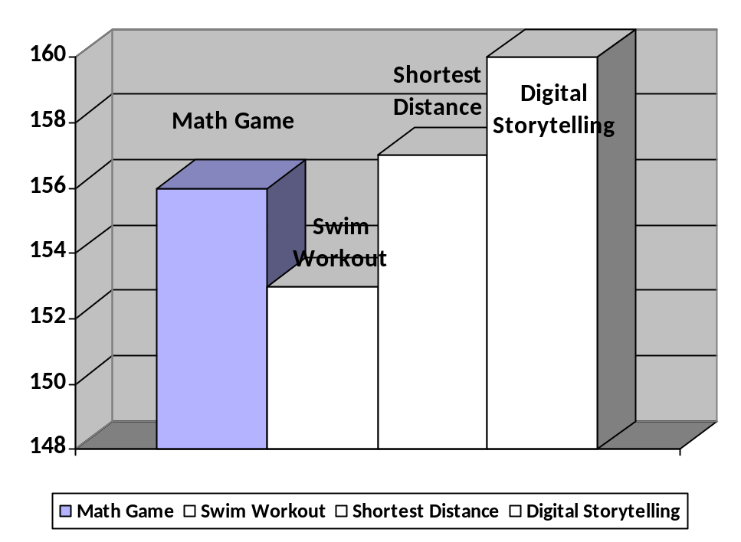

6. Evaluation Report

- CBI Program: Math Game

URL: http://www.sheppardsoftware.com/mathgames/mathman/mathman.htm

Evaluation: This is an excellent CBI website on “How to practice arithmetic while gaming”. It provides enjoyable events and interactive techniques to practice various mathematical calculations. Teachers of elementary schools can use this program to practice simple mathematical calculations, like: addition, subtraction, multiplication, division, and simplification calculations to the young children, in the manner of gaming.

It has an interactive graphical interface, and easy to play access. Students at very elementary levels can enjoy this game. When testing this program for evaluation, I was very much fascinated in its design techniques, use of information, and simplification of instructions. It really encouraged me to develop new CBI programs in future.

It is designed with adequate number of information and technology, and their balanced used. This is why, it seems to me an excellent CBI program.

Score obtained in every phases of CBI design methodology, in my evaluation, are shown hereafter.

CBI Program | Information (40) | Design of Info. (40) | Technology (40) | Design of Tech-Use (40) | Total  (160)
Math Game: arithmetic | 40 | 38 | 38 | 40 | 156

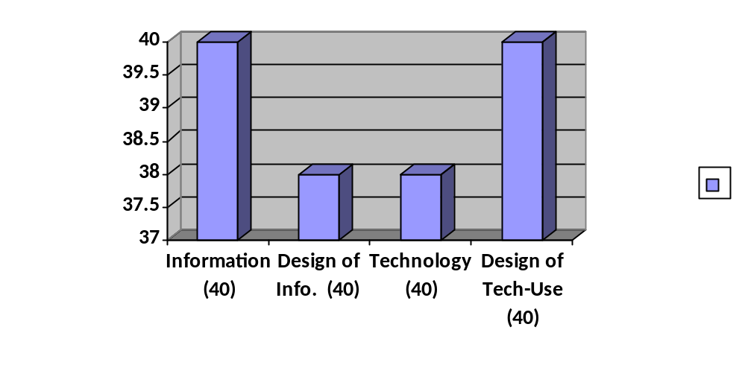

- CBI Program: Introduction to Swim Workout

URL: http://ruthkazez.com/IntroToSwimWorkouts.html

Evaluation: This is an excellent CBI website on “How to learn Swimming”. It provides full instruction to its reader to learn how to learn swimming.

Its instructional descriptions sequences are really helpful to simulate swimming. It provides instructions of different kinds of swimming techniques, and guideline to be a champion in swimming. Its instructional pictorial descriptions are really helpful to simulate swimming. Its PowerPoint presentation provides a lot of images of swimming. I was very much encouraged in its design techniques that helped me to gain a lot of new idea to design such a CBI program.

Score obtained in every phases of CBI design methodology, in my evaluation, are shown hereafter.

 | Score Obtained in
CBI Program | Information (40) | Design of Info. (40) | Technology (40) | Design of Tech-Use (40) | Total  (160)
Introduction to Swim Workout | 39 | 38 | 38 | 38 | 153

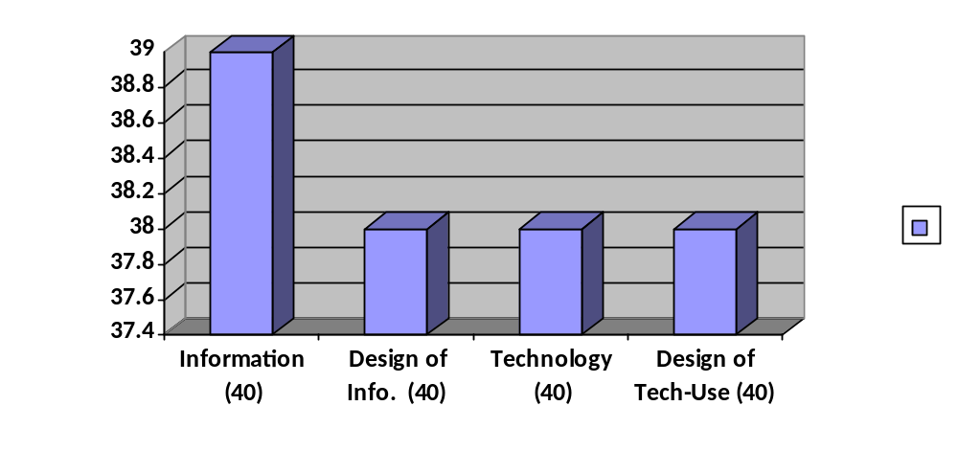

- CBI Program: Shortest Distance between two Points on a Plane

URL: http://members.tripod.com/~Paul_Kirby/vector/Vclose.html

Evaluation: This is an excellent CBI website on “How to find out Shortest Distance between two Points on a Plane”. This program provides a clear cut idea of representing points on a three dimensional plane, and the way to calculate shortest distance between the points on the plane.

It has been designed mainly for the students of high-school or college levels. However, students of these of higher than these grades my be benefited by it. It’s three dimensional graphical representation of points, and vectors really make it clear to understand, and to find out shortest distance between the points. When I was testing this program for its evaluation, I recalled my past time when I was a college student, and spent how much time to understand this.

It is designed techniques with sufficient information, and use of technology encouraged me to evaluate it as an excellent CBI program.

Score obtained in every phases of CBI design methodology, in my evaluation, are shown hereafter.

 | Score Obtained in
CBI Program | Information (40) | Design of Info. (40) | Technology (40) | Design of Tech-Use (40) | Total  (160)
Shortest Distance between two Points on a Plane | 40 | 38 | 39 | 40 | 157

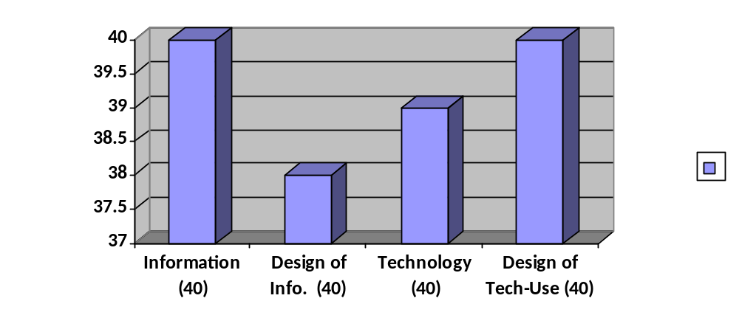

- CBI Program: How to Create a Digital Story

URL: http://www.umass.edu/wmwp/DigitalStorytelling/How%20to%20Create%20a%20digital%20story.htm

Evaluation: This is an excellent CBI website on “How to Create a Digital Story”. It provides step by step instruction to design a Digital Storytelling program. Students/Users/Storywriters of advanced level in using Information Technology definitely will be benefited by this program to make digital story with the composition of personal/family photographs, recorded voice narrations and multi-media productions.

It has an interactive graphical interface, and some relevant examples of digital storytelling programs, and list of necessary resources needed for making such a program. It’s designed techniques with adequate number of information and use of technology, really encouraged and let me learn more to me a CBI program by myself.

Score obtained in every phases of CBI design methodology, in my evaluation, are shown hereafter.

 | Score Obtained in
CBI Program | Information (40) | Design of Info. (40) | Technology (40) | Design of Tech-Use (40) | Total  (160)
How to Create a Digital Story | 40 | 40 | 40 | 40 | 160

